COVER PAGE

Course code: WSOA3003A

Student number: 2152594

Name: Jodi Chapson

Assignment: Reflection and Analysis on Assignment 2

Due: 1st of April at 14:00

For this assignment, we were required to build on our previous Unity Project from Assignment 1: a turn-based combat game with a focus on data design and the usage and manipulation of data to change and influence the game. The focus of this prototype was on communication design: what information is vital to the game and how this information is communicated to the player through various means be it visuals or sound, among other things. This is Into the Dark – prototype 2.

Prototype 1 was left at a basic turn-based combat game with no animations or visual/particle effects. In terms of UI: there were individual health bars for enemies and players, that floated above them during the whole game – regardless of whether in or out of combat (see Appendix 1). This was originally so that a player would always know how much health they and/or the enemies had, even if they were not fighting at present. During battle, special buttle HUDs would appear (see Appendix 1) that would display the health and damage stats of the player and enemy, respectively.

In prototype 2, further revision found that simply having the green health bars floating above the characters at all times, was not particularly helpful in communicating information on health. The health bars themselves could only represent how much health a character had in relation to their max health and could not communicate a concrete number such as 5 or 12. Looking at the health bar alone, one has no means of gauging how much health there originally was, and exactly how much health there was left, so it became somewhat irrelevant and a waste of screen space. That being said, the green health bar communicated information much faster than say, a roster of closely clustered numbers at the corners of the screen: representing health and damage. Another note: I felt that having two different pieces of UI (the health bar and the battle HUDs) that both were intended to

Also some quality of life changes as well: such as shadows to make the characters look more grounded and existing in the world lmao. Fixed an issue where health bar: when full, did not appear entirely full, and when health was below 0, still showed a small sliver of green in the health bar.

The current HUD suits 1v1 fights. However if I were to expland the game to feature multiple characters in a fight, the current UI, tho comparatively less clunkier and more compact that the UI of prototype 1, would take up way too much space as each character will have to have their own battle profile. If it comes to it, these may need to compacted even more so that the screen is not majority battle huds lmao.

~~As per our brief, I intended to make a simple, turn-based combat game that would feature not only 1v1 combat, but later grow into team vs team combat, such as in games like Fire Emblem: Three Houses, Lost Sphear, AFK Arena and, in a sense, Child of Light. I envisioned a small game where players could control a little squadron of characters – each one more different than the last, and each bringing new strategies, attacks and combat mechanics to the game. I wanted to include many means of customization for the players – such as a wide variety of weapons and armour to equipped and use, potentially an inventory for holding special items, or a shop for buying upgrades.~~

APPENDIX 1

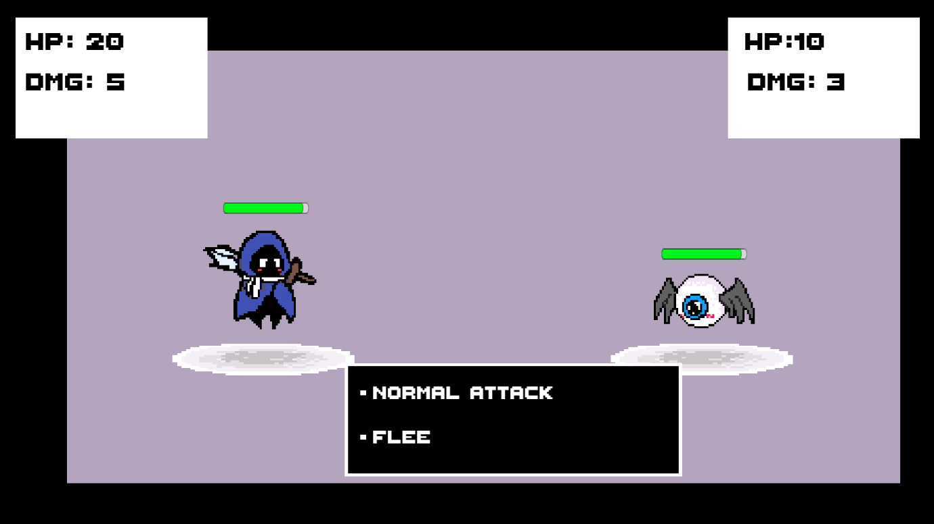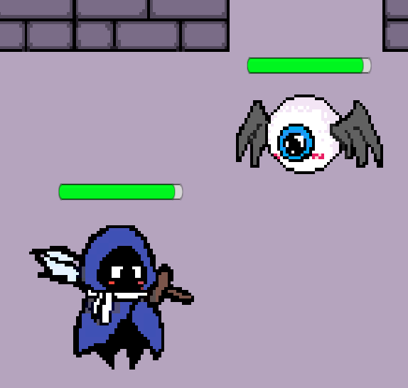

Protype 1 UI: for in-combat (above) and out of combat (below)

APPENDIX 2

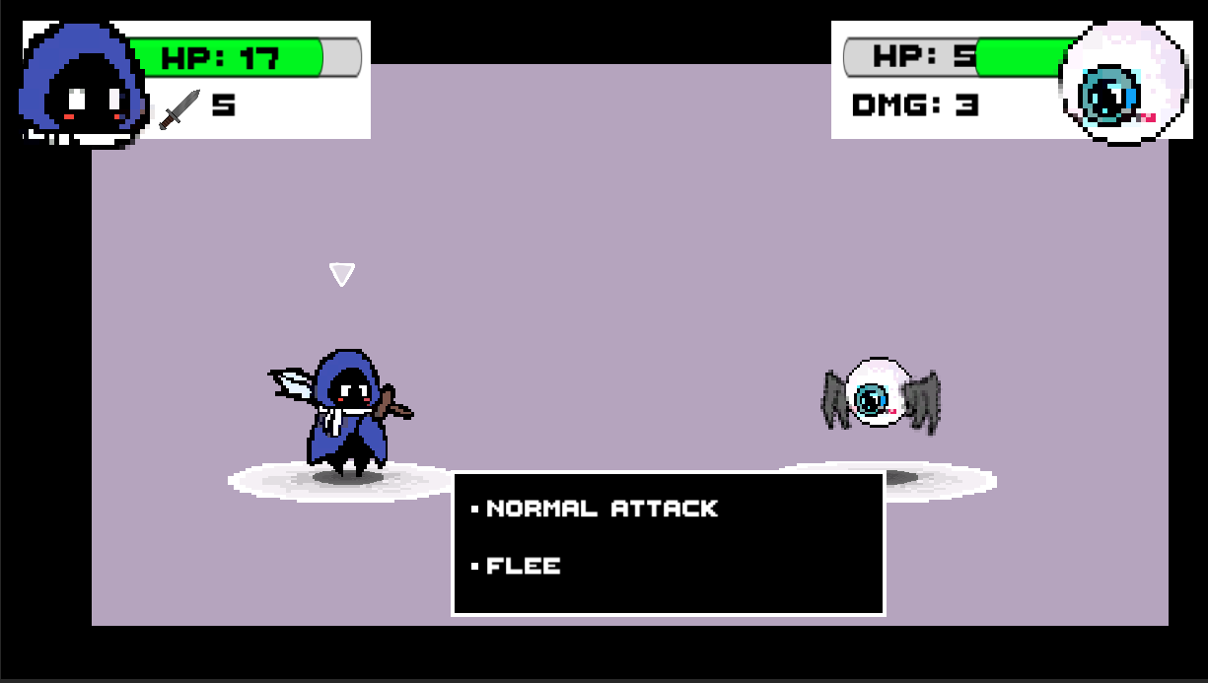

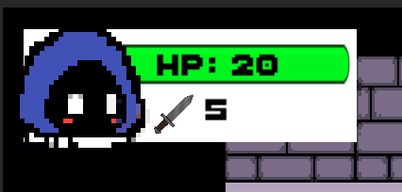

Protype 2 UI: for in-combat (above) and out of combat (below), featuring the new player/enemy HUDs and arrows indicating turn.